**Task 12: Triggering PollSCM Build & confirming it with an Email Triggering, Parameterized Build Added**

The **Poll SCM** (Source Code Management) trigger in Jenkins is used to check for changes in the source code repository at regular intervals. When changes are detected, Jenkins triggers a build automatically.

A **parameterized build** in Jenkins allows you to pass user-defined input parameters to a job at runtime, enabling flexible and dynamic builds. Instead of hardcoding values, you can specify parameters like environment variables, version numbers, or configurations to customize how the build executes.

1. **Started the Jenkins & created a freestyle job named Pron_Cron_Email**

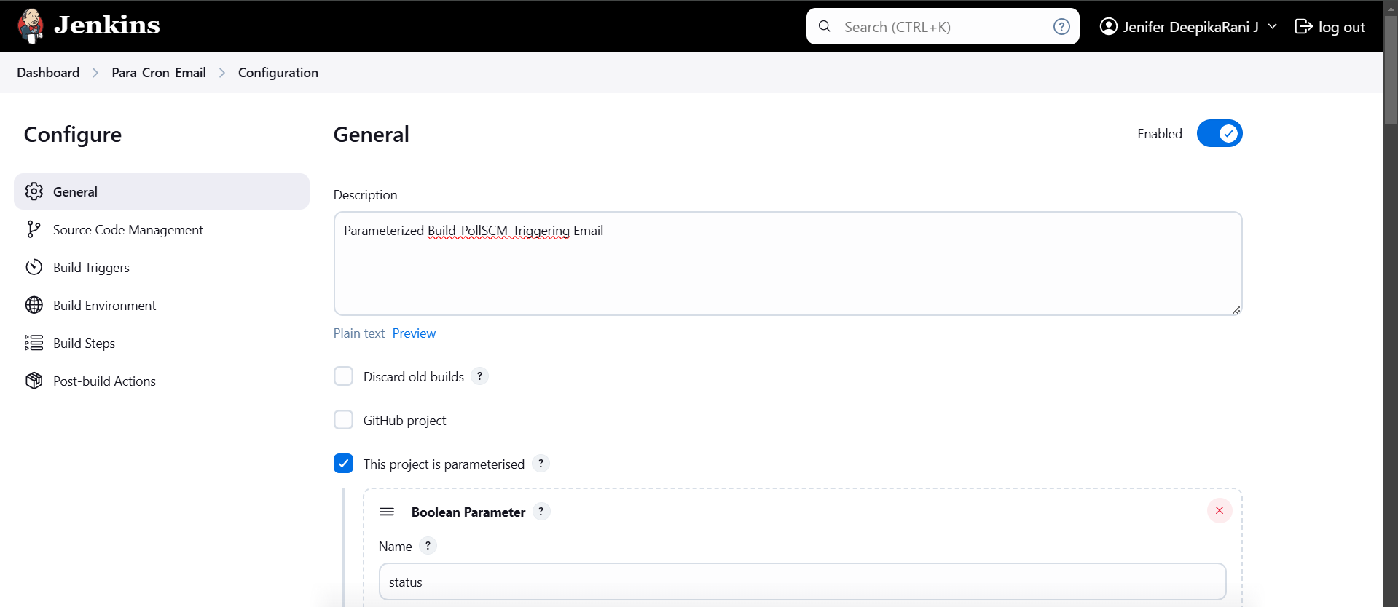

1. **Configuring Parameterized Builds**

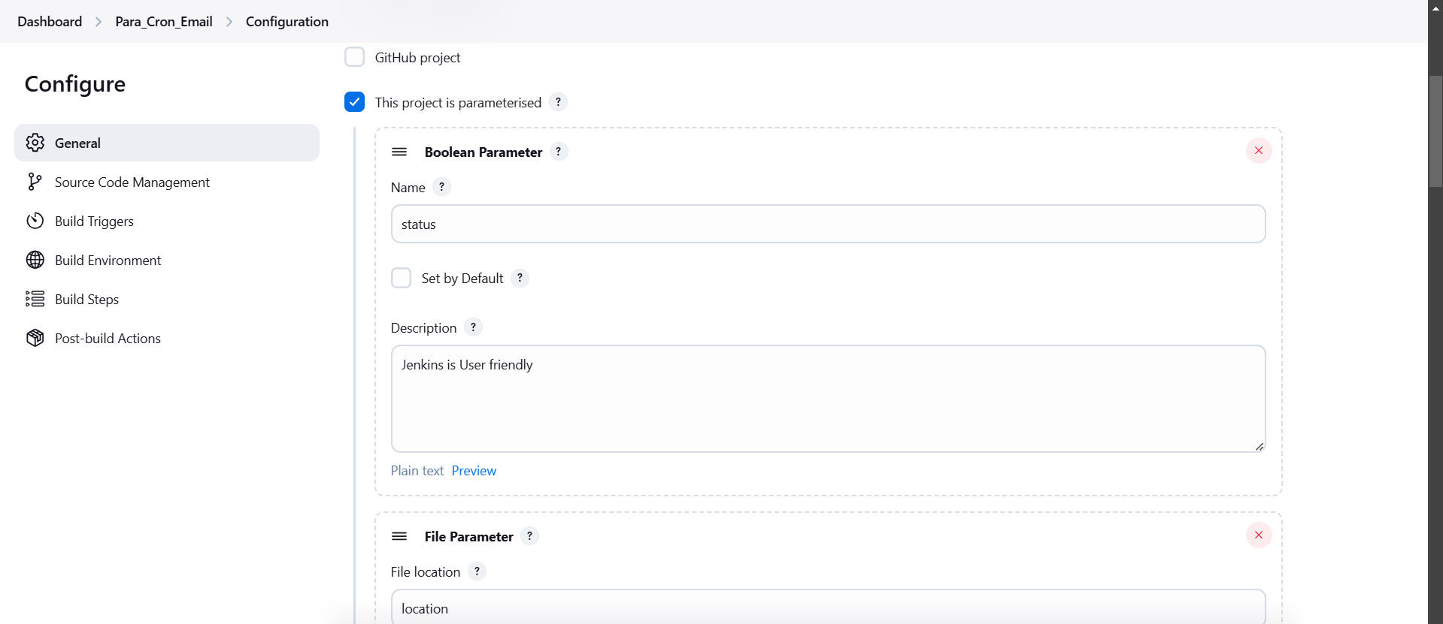

A **parameterized build** in Jenkins allows you to pass user-defined input parameters to a job at runtime, enabling flexible and dynamic builds. Instead of hardcoding values, you can specify parameters like environment variables, version numbers, or configurations to customize how the build executes.

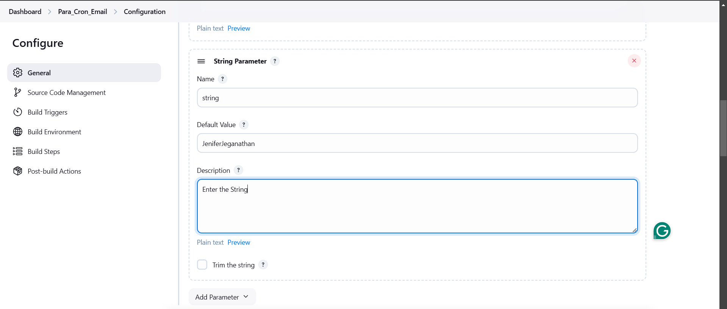

1. **Configuring Git Repository(SCM)**

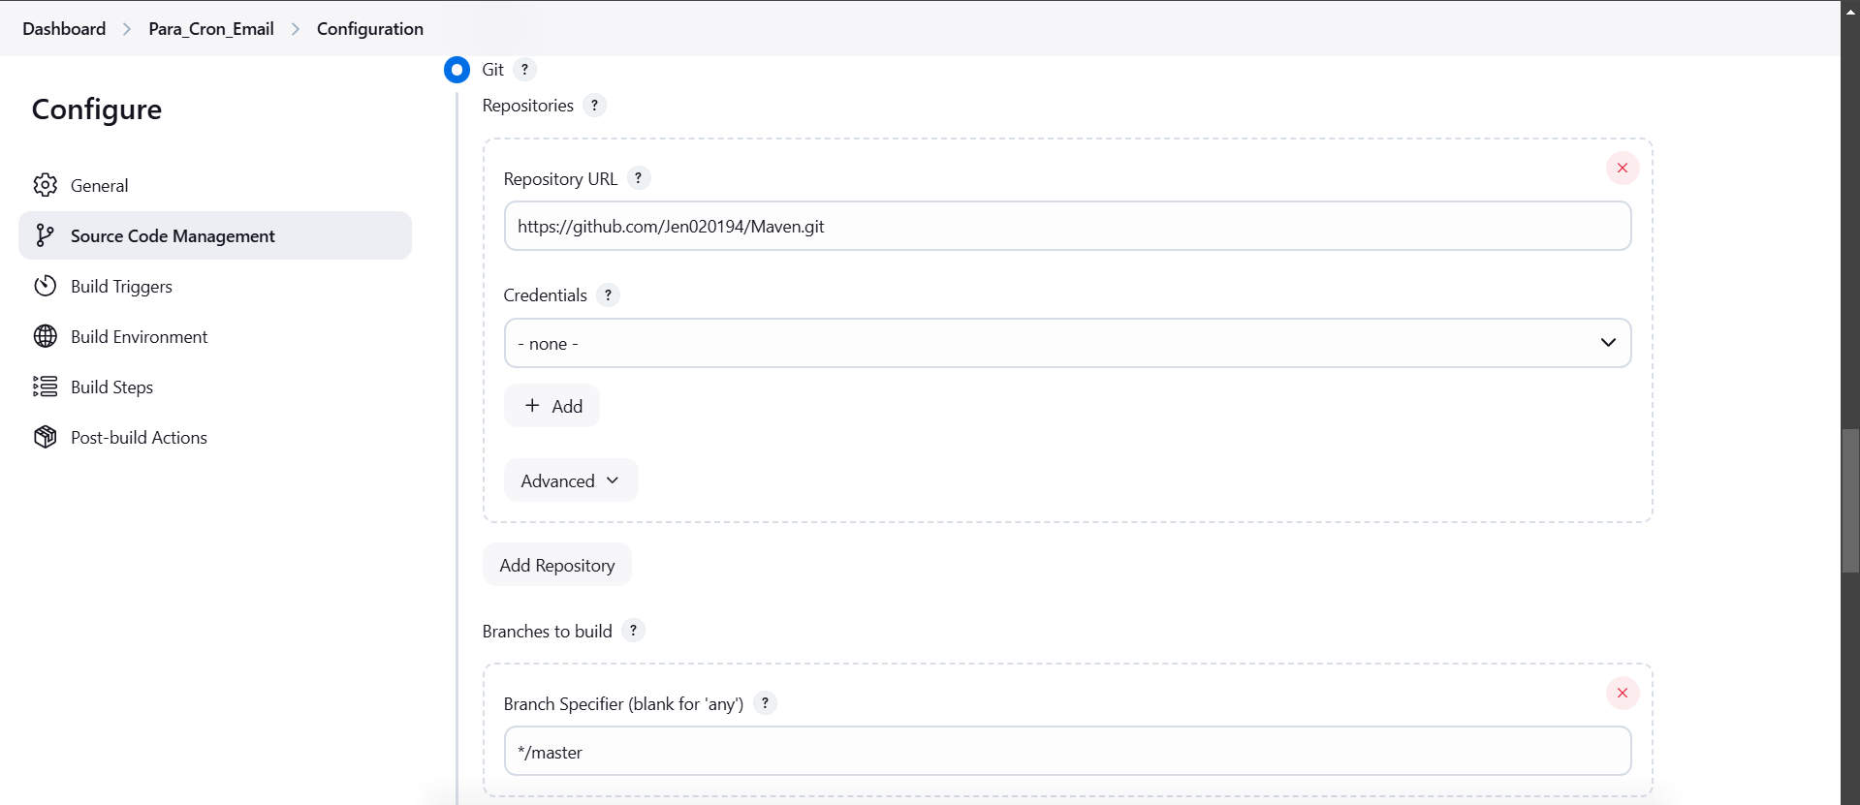

1. **Scripting the Shell execution to get the value for the Chosen Parameters**

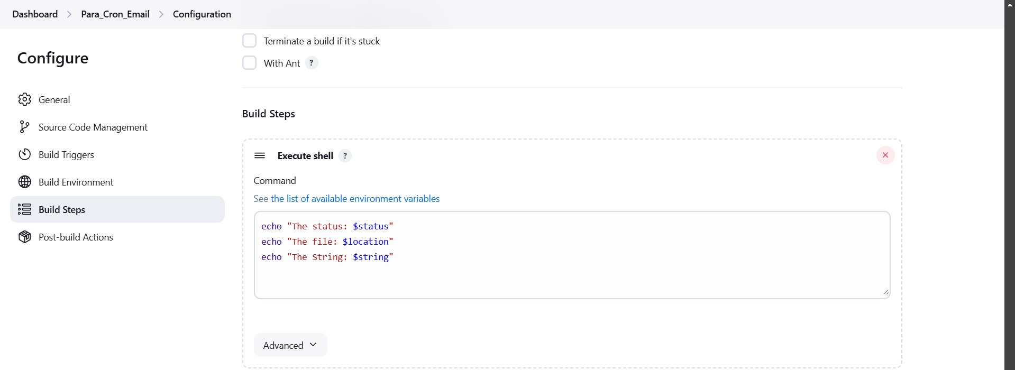

1. **Configuring Editable E-mail Notification**

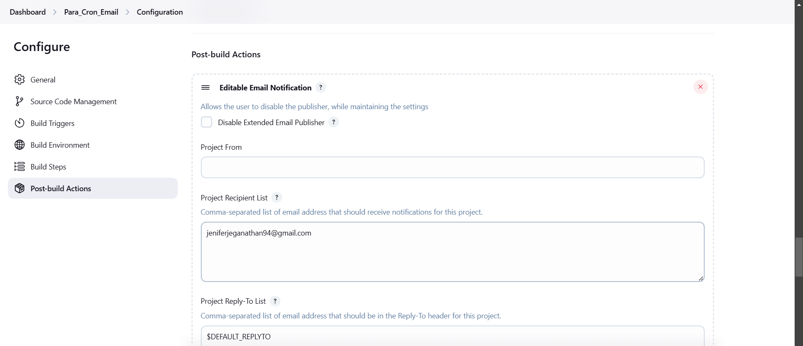

1. **Modifying Git Repository Readme file**

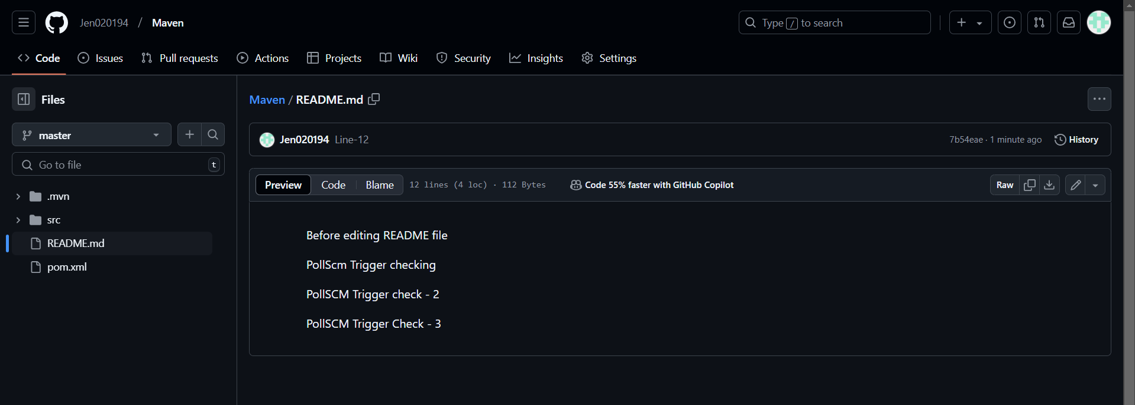

1. **The Console Output with default Parameters setting**

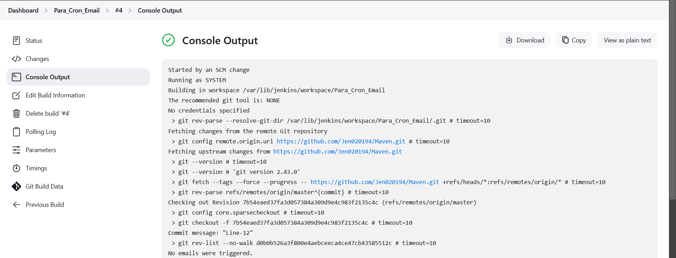

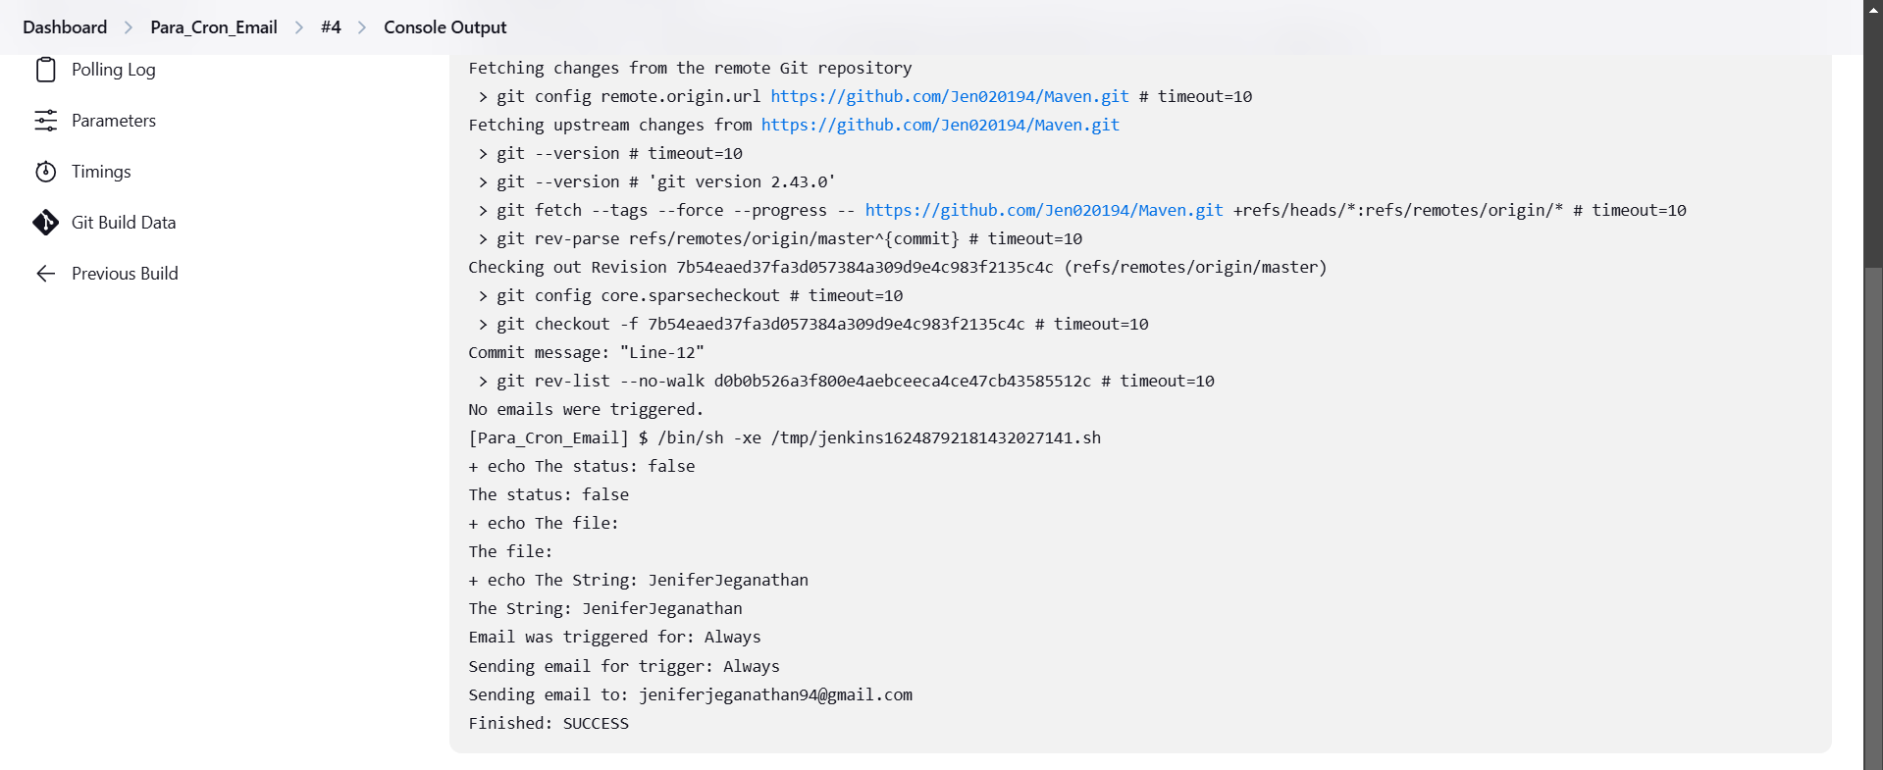

1. **The Console Output Customized Parameters setting**

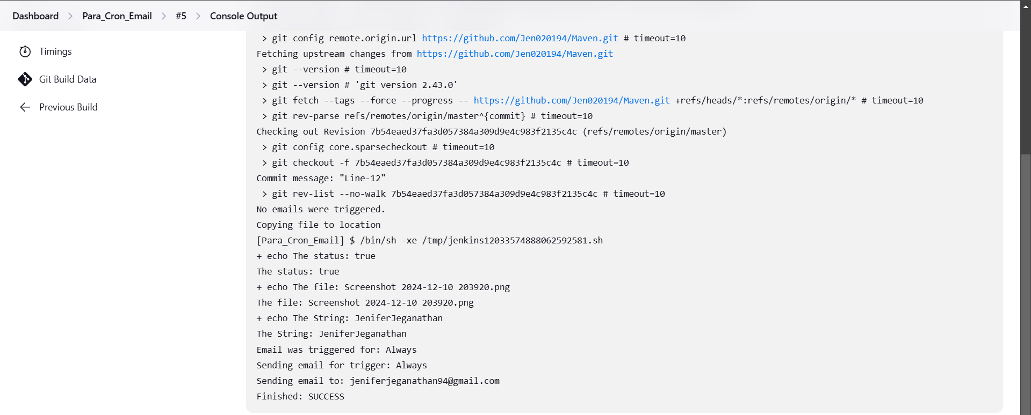

1. **E-mail Triggered to the given Recipient Mail id successfully**

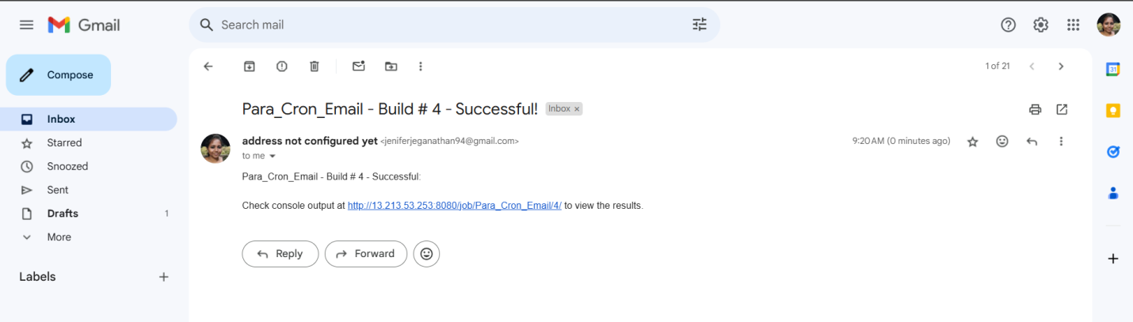

**A brief Comparison of Periodically builds, PollSCM & Webhook Triggers:**

1. **Poll SCM**:
   * Checks for changes in the repository at scheduled intervals.
   * Builds only if changes are detected.
   * Example: H/5 * * * * (every 5 minutes).
2. **Build Periodically:**
   * Triggers builds at fixed intervals regardless of changes.
   * Example: Nightly builds (H 0 * * *).
3. **Webhook:**
   * Real-time trigger when changes occur in the repository (e.g., push, pull requests).
   * Requires repository integration.

**Key Difference:**

* **Poll SCM:** Periodic + builds on changes.
* **Build Periodically:** Periodic + always builds.
* **Webhook:** Instant + builds on changes.